**Selected video works**

**Bodil Furu**

**Mangeurs de cuivre**

HD video, 82 minutes, 2016

Commissioned by the Biennial of Moving Images 2016, Centre d'art Contemporain, Genève, Switzerland. Curated by Andrea Bellini. Co-Producer Cente D'Art Waza de Lubumbashi.

***Mangeurs de Cuivre*** shows the reality of multinational mineral extraction in the south east of the Democratic Republic of Congo. An experimental combination of voices and landscapes, merged with a rich historical heritage give us access to unique micro sorties hard to discover from a sub Sahara Africa.

DRC has a long history of civil wars and conflicts caused by minerals. There are still wars going on in the east of Congo nourished by global power structures interested to keep political instability to easier access minerals. In the south east of DRC there is a 300 km long copper belt. Here we find multinational operators that controls most of the extraction industry today.

*Mangeurs du Cuivre*portrays stakeholders in the copper mining industry representing highly different interests and positions. By following a 'community adviser' working for a mining company, this film reveals situations where a corporate social responsibility language is used to pacify the local population and gain trust. We meet a traditional village leader with no formal power. In his daily work he struggles to represent local traditions in meeting with modern regulations and urban development. A local businessman is trying to get acceptance in international business to show that Congolese economists are able to do business in their own country.

*Mangeurs de Cuivre* (Copper eaters) is the precolonial way of melting copper. Before colonization it was performed as rituals. This activity was banned when the Belgian started to extract copper industrially. This film portrays this ceremony conducted by a group of men wanting to keep this heritage alive. The ritual is accompanied by an ancient legend about the spirits that since early days have controlled the amount of copper in the ground. Performed by Congolese actors this story works as a historical reminder of the never ending interest conflict in DRC caused by minerals.

Mangeurs de Cuivre explores the global economy in the meeting with local tradition and identity, rendered into a contemporary global perspective.

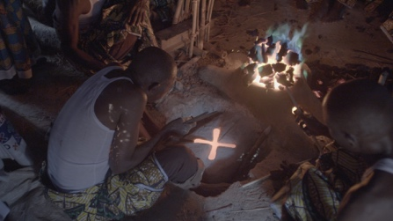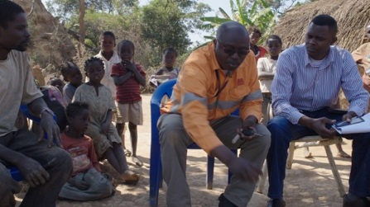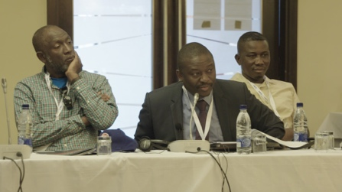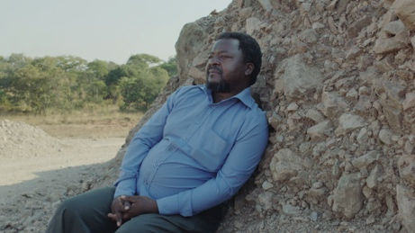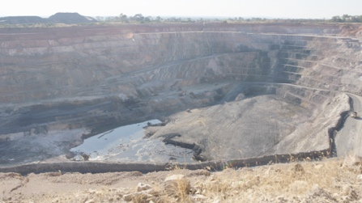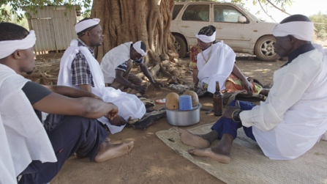

**VIMEO LINK**

<https://vimeo.com/190940085>

Password : Lunsebele

**LANDSCAPES BY THE BOOK**

HD video, 37 minutes, 2015

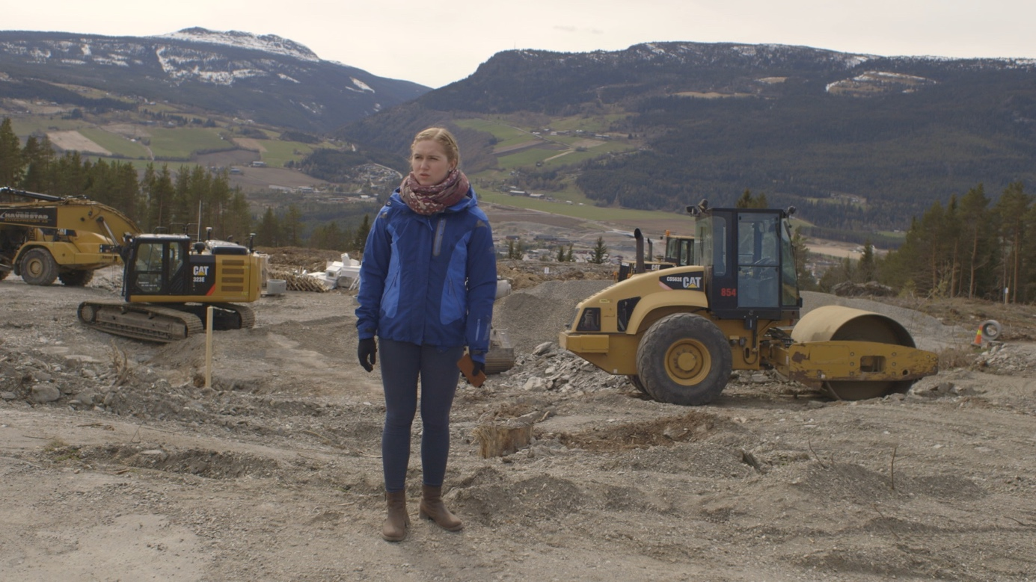

Commissioned by Harpefoss Hotel, curated by Eivind Slettemeås.

*Landscapes by the book* is filmed in the municipality of Fron in Norway. The film portrays the alteration of landscapes through flooding and highway construction, and it’s effects upon the people inhabiting these places. Another focal point for the film is the now rejected plans for development of a new hydroelectric power plant in the river Lågen, where both supporters and protesters reflect about what might have become the consequences. The film dwells about risk-taking and how common land(scapes) are affected by modernity and big society. By the use of local myths and traditional music the film shows us more than the actual landscapes might reveal to us.

**Video Link**

https://vimeo.com/139922526

PWD: landscapes2015

**CODE MINIER**

HD video, 45 minutes, 2013

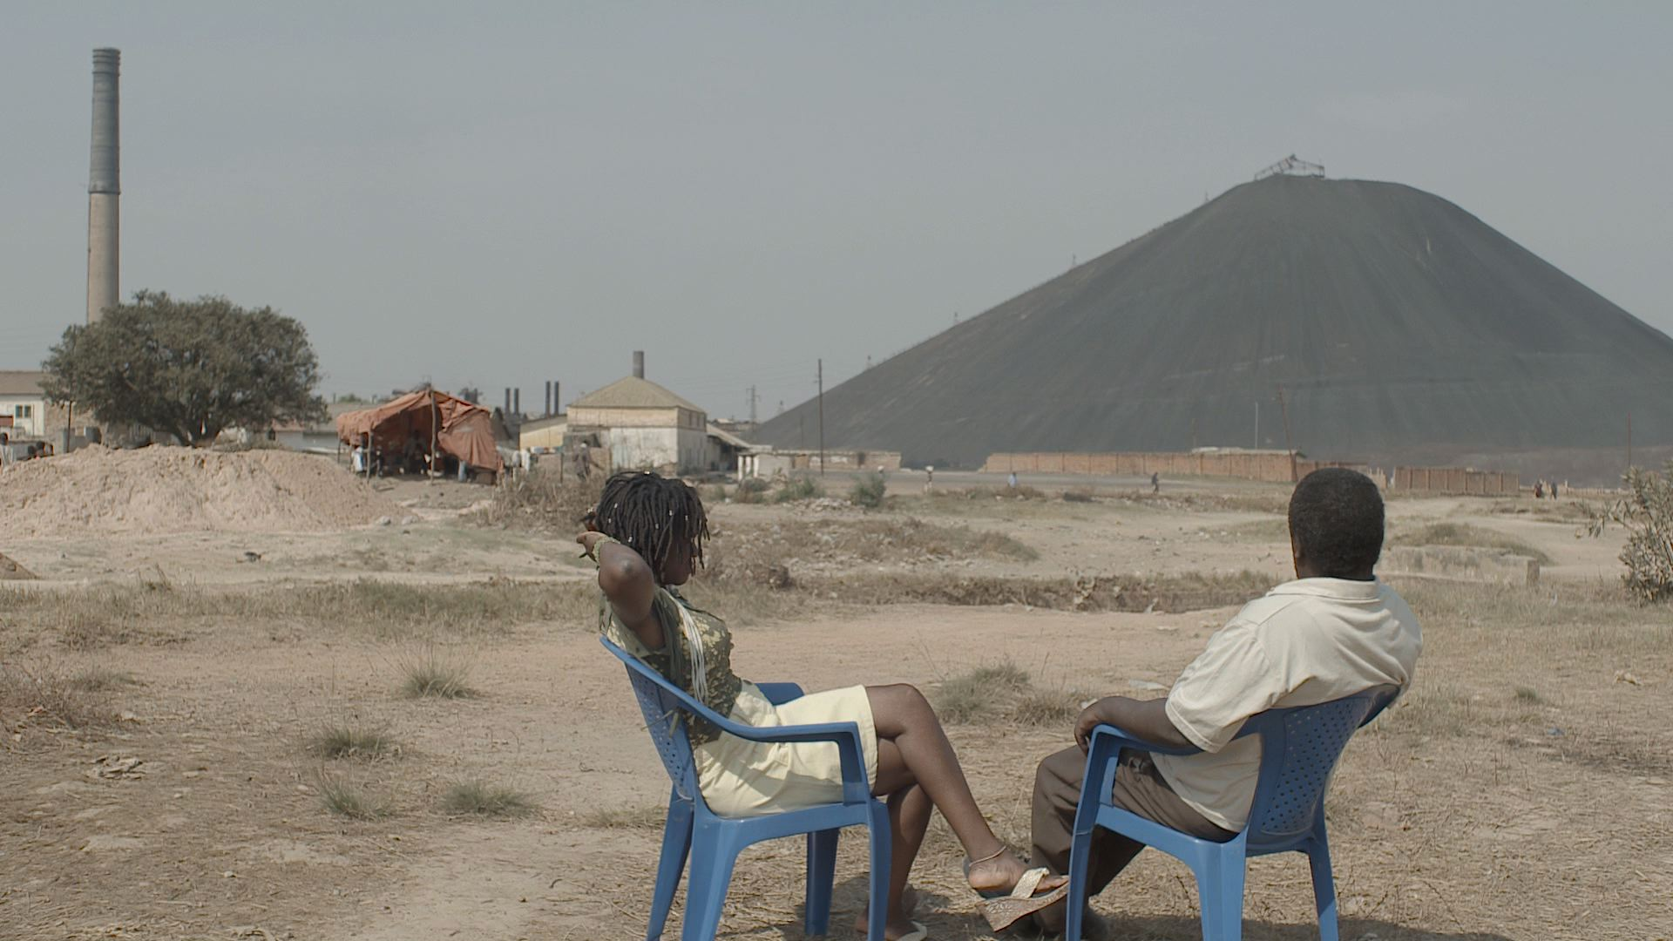

*Code Minier* is the name of the Congolese mining law, implemented in 2002 as requested by the IMF and the World Bank. It was seen as a necessity to attract foreign investments and multinational mining companies to a war- ridden and bankrupt country. Code Minier follows different figures that has direct experiences of copper mining, a replaced villager, a business man, a politician, a mine worker and a local Chief cotuimer. Like characters in drama they each present their sights, a patchwork of views that is as fragmented as the contested landscape itself, as they offer contrasting views of the copper’s significance and future role.

The visual frame of the film is carried out by a series of cinematic tableaux. In a layer of fiction two actors are placed in various landscapes and situations, their dialogues reflect upon the earth, the law and the history in a metaphorical way. We can understand the copper as a talismanic force through which the landscape is potentially transformed, by people trying to find a fortune, and left is the people trying make a living.

**Video Link**

https://vimeo.com/86228522

password: furuproduction

**MISTY CLOUDS**

HD video, 52 minutes, 2011

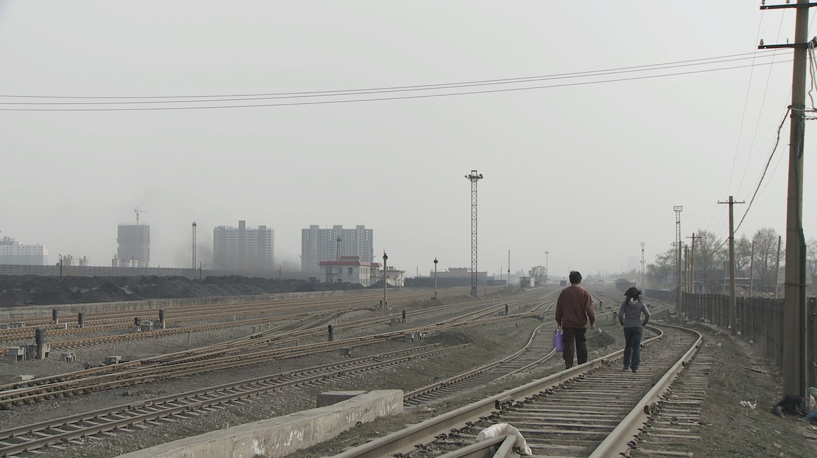

*Misty Clouds* is filmed in Taiyuan in the province of Shanxi in Northern China where half of the country’s coal energy is produced. The video portrays environmental engineering students and citizens of Taiyuan and their reflections on the production of coal, health, urban planning, and financial structures. Larger environmental questions are juxtaposed with the personal experiences of individuals living under extreme pollution. The film balances the factiously staged and the documentary.

**Video Link**

[https://vimeo.com/80772967](https://vimeo.com/80772967?utm_source=email&utm_medium=clip-transcode_complete-finished-20120100&utm_campaign=7701&email_id=Y2xpcF90cmFuc2NvZGVkfDM2ODViMmM1NjVhMDAwMmVkODBmN2E2MWNlN2UwN2Q3MjczfDE3Nzk0MjY5fDEzODU5NzE3ODJ8NzcwMQ%3D%3D)

PWD: furuproduction

**WHERE MOUNTAINS FALL**

2012. 58 minutes. HD video

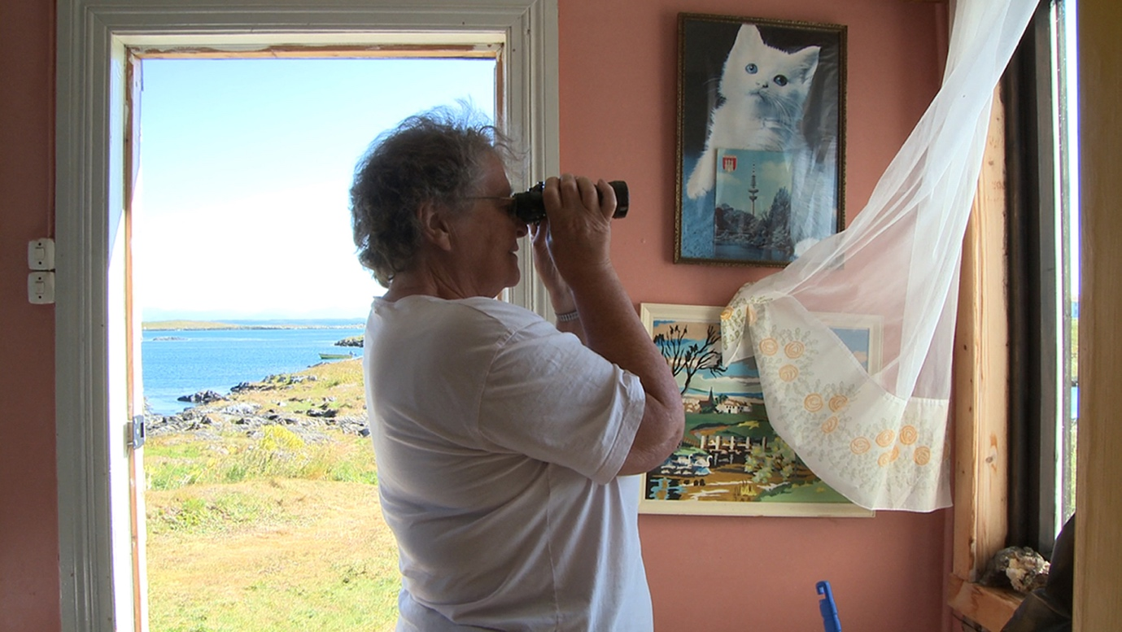

*Where Mountains Fall* tells the stories of Anna Stensholm and Anne Lånan, who were the last inhabitants that left when the islands Lånan and Hinskjæret in the Vega archipelago in Northern Norway. The islands had been cultivated for 1000 years until they had to be abandoned. After the Second World War the Norwegian government subsidised moving to the islands until the late 70ies. Due to a more centralised settlement policy the islands were then given up and are now only inhabited during the summer to tend the eider ducks and to collect the eider down feathers. In this film they return to the islands together with the filmmaker and recount: how did they manage to get along in this environment, to survive and to navigate it? The two women activate their memory of a longlost time – they present us their story of a bygone life on the island. Their personal stories and reflections take us through nostalgia and the beauty of nature, and offer an insight into the physical and psychical strategies of coping with rough weather as well as everyday life in a small community. Furu follows the gradual reconstruction of memory while speaking – a film about a specific past – a flow of memories, a told self-assurance. Social control, exclusion of the newcomers and in-laws, possible alternatives, struggle with and symbiosis with nature are discussed: Not only dealing with wind, weather, and waves was arduous – living together in a closely-knit community manifests itself as at least as difficult, every step and action was watched and commented on by neighbours. Both women sensed this especially since they were newcomers and in-laws themselves and they describe their resistance against it. In Furu’s description of the two women and the depopulated island communities, general and existential questions rise to the surface.

Video Link

[https://vimeo.com/80201530](https://vimeo.com/80201530?utm_source=email&utm_medium=clip-transcode_complete-finished-20120100&utm_campaign=7701&email_id=Y2xpcF90cmFuc2NvZGVkfGRhYjUzOTZkODM2ZGVkMWQzODBmODQ2Zjc5YjAzMTg1NDIzfDE3Nzk0MjY5fDEzODUzMjY2Mzh8NzcwMQ%3D%3D)

PWD: furuproduction

**OPERA**

35 mm (1:1,85). 13 min. 2008

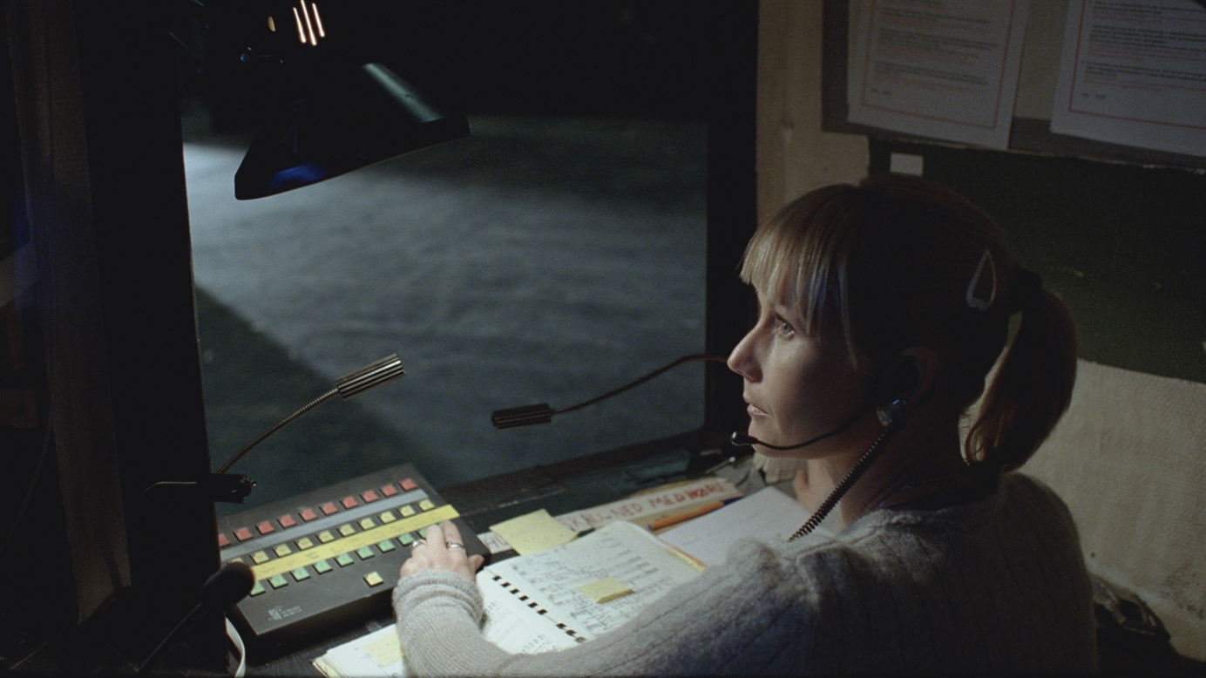

OPERA is Furu’s first 35 mm film. Furu captures the atmosphere from behind the scenes in Norway’s first national opera house as the country holds its breath for the much anticipated opening of its replacement. Her inquisitive and direct focus point is the invisible work of the backstage crew who play out their roles behind the scenes. The film turns the usual hierarchy of opera production up side down and places the backstage staff – the foundation blocks in the pyramid – in front of the camera whilst the director and singers are out of the picture. Furu’s emphasis on social hierarchies draws a parallel towards the building’s history as a part of the Norwegian history of early social democracy. The building was established in 1935 and was conceived as a theatre for the workers and inspired by similar ideas such as the German workers’ theatres, Volksbühne. These theatres aimed to enlighten and instruct the working classes. The construction of the building was part of a national employment strategy for out of work sailors and casual workers between the wars. The film creates a point of refraction between the opera’s pathos and social realism- the backstage crew’s work is aestheticised and elevated- and stands as a contrast to a tradition founded in elitism and bourgeoisie standards.

**OPERA (2008)**

35mm film, 12 minutes

http://www.youtube.com/watch?v=JvHykiJM584

OPEN, no PWD